Computer Networks Lab 09
Name: Hafsa Salman
Roll no. 22K-5161

Command: sudo mn (Display a basic network topology with 1 switch and 2 hosts)

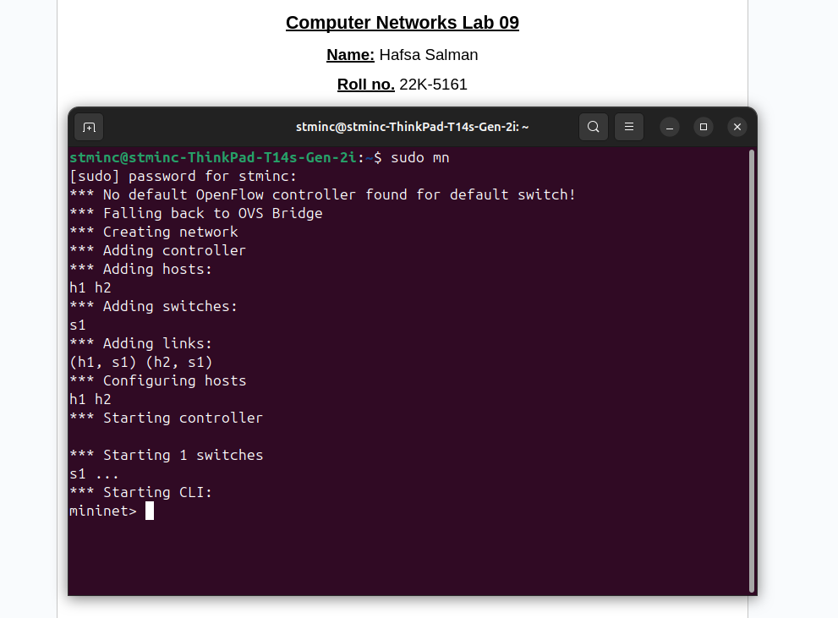

Command: help (To display all the commands in the mininet)
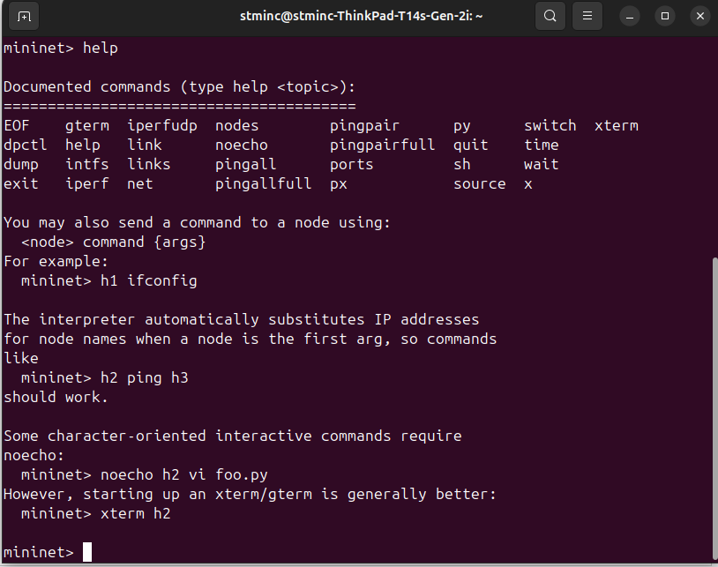

Command: nodes (Display available nodes)
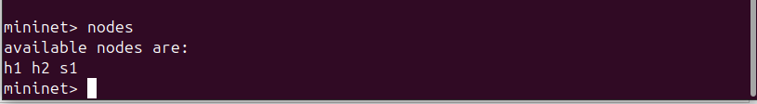

Command: net (Display links between the devices in Mininet)
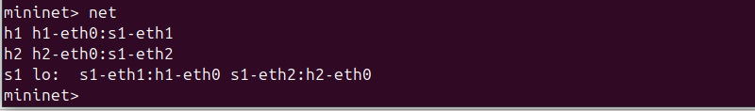
Command: h1 ifconfig (Shows h1’s interfaces)
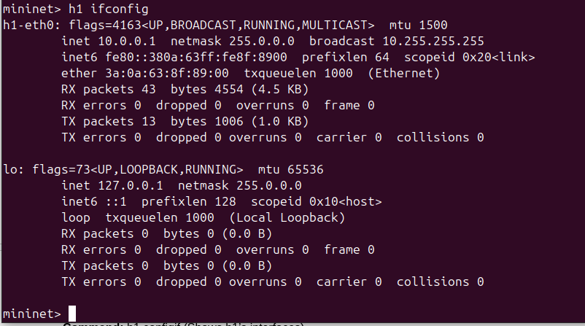

Command: h1 ping 10.0.0.2 (Testing the connectivity between h1 and h2)
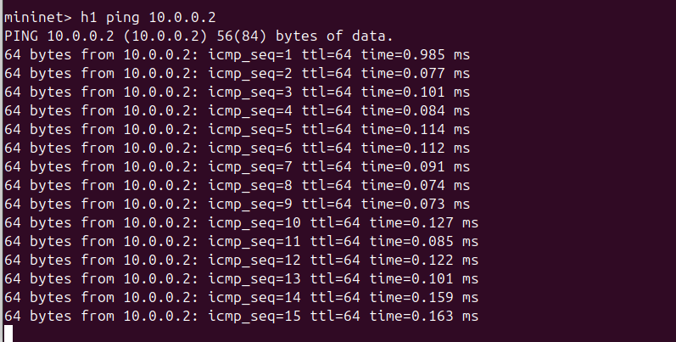

Command: exit (Stops the emulation)
